**Task4**

1. Research Design:

I will be using a Mixed Method approach for my specific dataset.

Apart from having quantitative data, I wish to conduct interviews to also have qualitative data about my prototype.

Quantitative data will help me to compare individuals as I will have a measured numeric value on how fast that they will conduct a task in my prototype. However different people with different experiences with IT will have different quantitative data. This is because a small simple task can be easy for experienced users but can take time for less experienced users. For this reason, I wish to conduct an interview before and after the usage of my prototype. To have a qualitative data to show how experienced is the user and how they felt when using the prototype.

Qualitative data will show how the users will use the prototype, as different people can react slower or faster as they can have more or less experience with IT specifically with AR.

Qualitative data is also useful in my research design process as I will be conducting individualized interviews with users that tested my prototype to have a qualitative opinion on my prototype. The interview will be conducted with questions to know how different experienced users will answer the questions related to my prototype.

I will also have a quantitative data to show how much time different specifications of smartphones will differ from one another using my prototype.

1. Research Methods

A small interview will be conducted before testing my prototype to know how their experience is with IT and Augmented Reality. This small interview will be used to compare with the quantitative data as different experienced users will have different quantitative data.

I will be giving the user small tasks that they need to do in my prototype to conduct how much time they will take to complete the task. The small task will include them opening the prototype via a QR code, allowing the web-based AR application to access the phones’ location and camera, and also displaying the needed information as a Visual Augmented reality. This quantitative approach will show how much time will different experienced users take to complete a task. A screen-recording application on the device will be used to record their testing. This will be used to accurately measure the time taken by the user to complete the given task on the phone.

Validity and reliability are characteristics that assess correctness and repeatability, respectively. The word generalisability refers to how well a small sample size represents the entire population.

To increase the dependability of the outcomes, the task must yield the same result when repeated. To get such a result, the work must be completed under the identical conditions each time. As a result, variables must be eliminated as much as feasible in order for it to be dependable.

A qualitative interview will be held after their usage of the prototype, to have feedback and suggestions for my prototype. This will show the feedback how different experienced users and how they felt by using this new technology.

Questions like “How was your generic experience with this prototype?”, “How easy was it for you to get the information that you wanted?”, “Do you think you will be using this prototype in the future?” and “What feature did you like the most?”. The answers to these questions will help me to improve the prototype in the future and have a generic overview from multiple different users.

If the interview is retaken numerous times and the responses are the same, I can obtain a trustworthy answer using a qualitative technique. To enhance this, extraneous influences that may impact the interviewee must be minimized or kept as constant as feasible between each participant.

Because the data acquired in interviews is not always straightforward when compared to quantitative data, I might have added inaccuracies relating to interviewee interpretation. Because the questions are semi-structured, it is possible that I, as a researcher, will arrange phrases that will impact the participant's response. I will take care not to remark on any response the participant may provide, since this might impact the data obtained.

The interviews are conducted one-on-one so that the participant may share his or her own thoughts and opinions.

In addition to user testing, I will also conduct how different specifications of smartphones will be used to use this prototype. This will tell me how the mobile phone hardware effects the usage of WEB-Based Augmented Reality.

Different browsers including Chrome, Firefox, Opera and Safari (on iPad) will be used to see how different browsers differ from one another and which gives the best experience for Web-Based Augmented Reality.

1. Research Pipeline

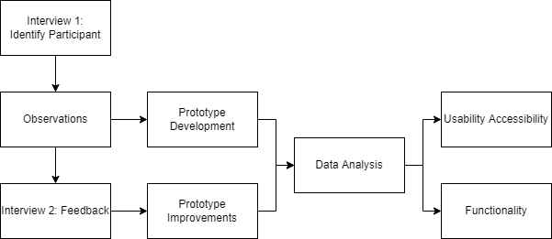

Firstly, the participants that are going to use and test my prototype should be identified.

Observations of the participants is important to gather information about how I can make my prototype more accessible to different users with different IT knowledge.

When I have observed the needs for the users, I then start to develop the prototype, keeping the observations in mind.

When the prototype is finished for testing, the participants should have time to use it. Then a 2nd interview will be done to have feedback and recommendations about the prototype.

Using the participants feedback and suggestion I will than improve the prototype to satisfy the need of the users. Again, Data Analysis will be used whilst using the prototype to have information whether the prototype improved in satisfying the needs.

From the data analysation process, I will use the data gathered to improve on the usability and accessibility, whilst maintaining the functionality of the prototype.